Population Change and Ratio
What you need and how it works

So to help you with this activity, each group will need the following….
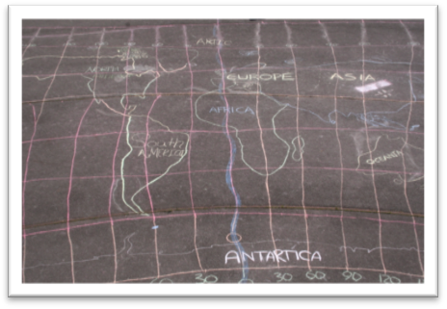

A map of the world like this one. Anything will do, but they should be at least A3 size.

Some counters in 4 different colours or similar. They need to be small enough for you to put lots of them on the map.

The aim is that you experiment with ratios and relative proportion by moving counters around on the map.
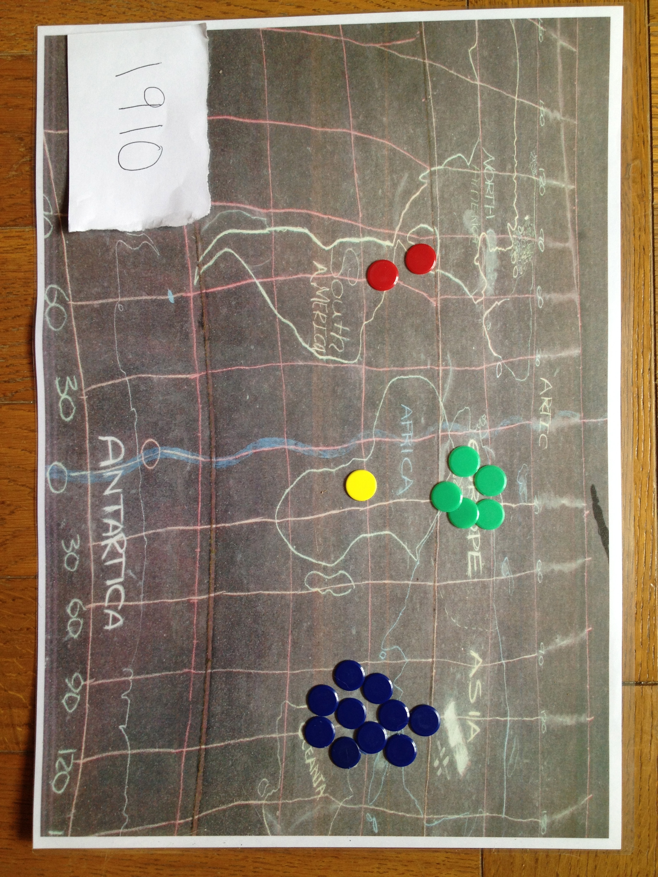

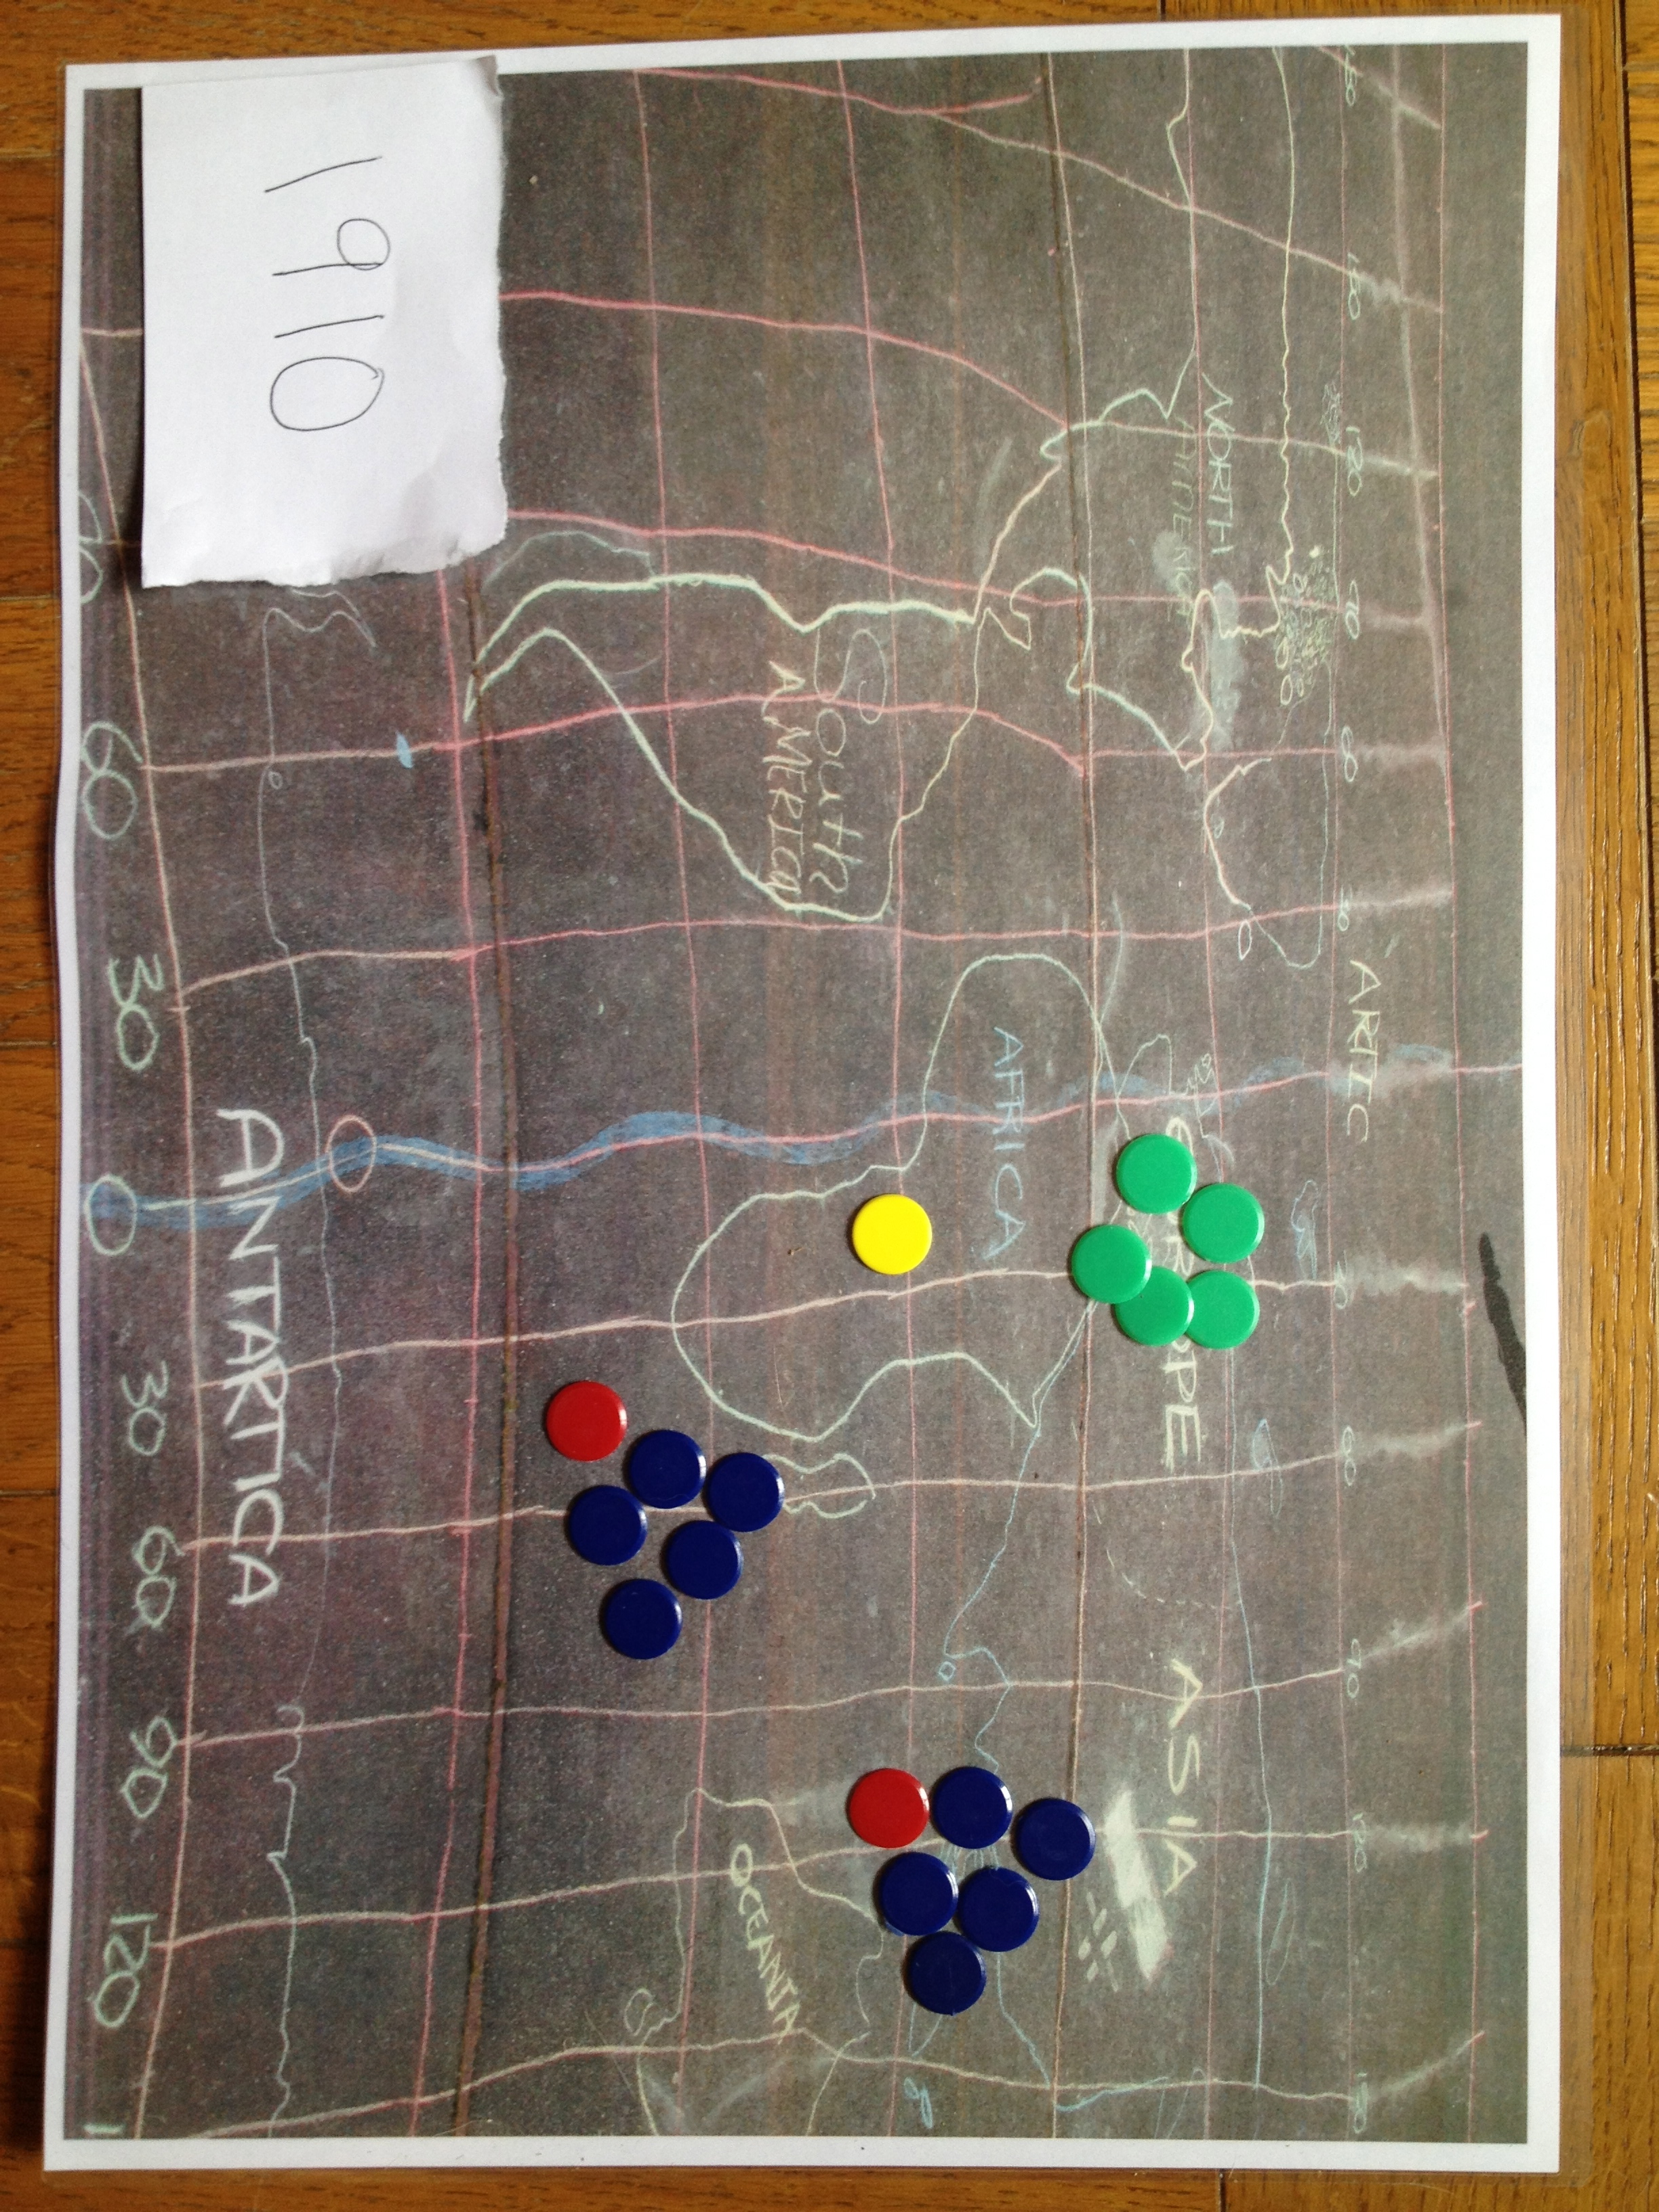
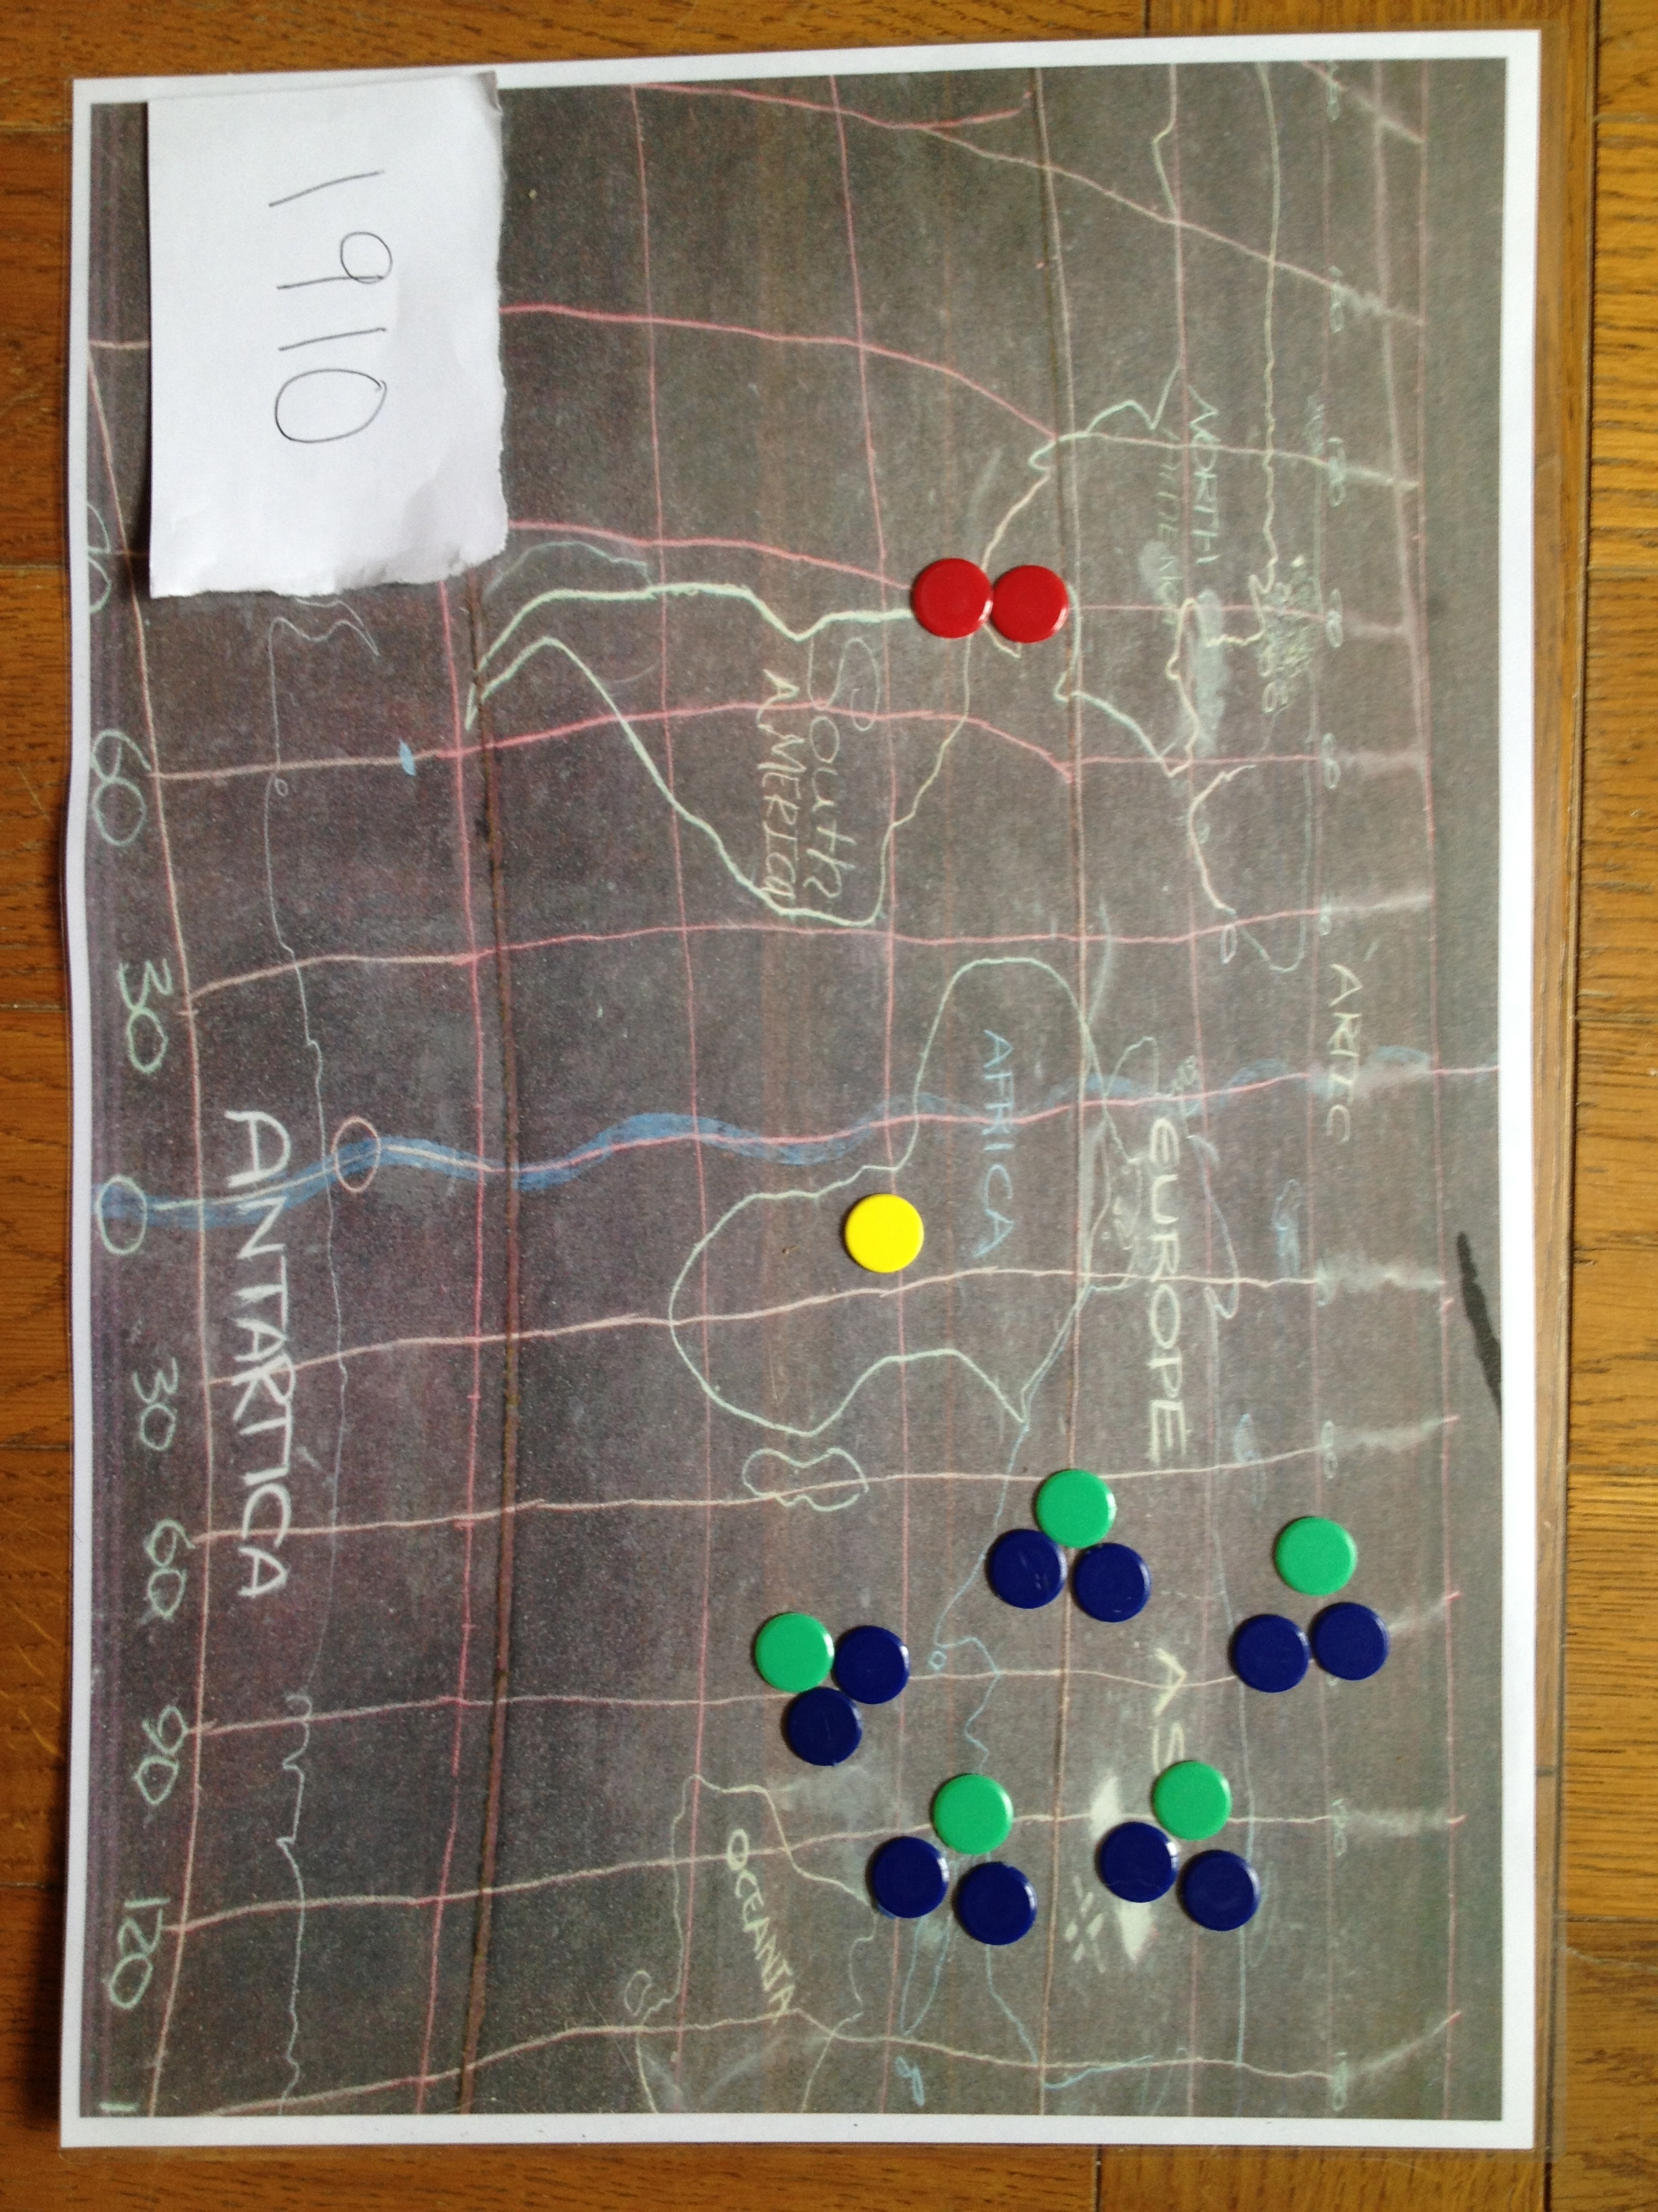
This picture on the left shows the data for 1910, with 10 people in Asia, 5 people in Europe, 1 person in Africa and 2 in the Americas. By trying to arrange the counters in to equal groups, we can get a ratio in its simplest form.

Here can see that the ratio of Americans to Asians is 1:5 and the ratio of Europeans to Asians is 1:2

Growth over the last 200 years

 | Population growth (1 person approx 93 million)
Year | Asia | Africa | America | Europe | World
1810 | 7 | 1 | 0 | 3 | 11
1830 | 8 | 1 | 0 | 3 | 12
1850 | 8 | 1 | 1 | 3 | 13
1870 | 8 | 1 | 1 | 4 | 14
1890 | 9 | 1 | 2 | 4 | 16
1910 | 10 | 1 | 2 | 5 | 18
1930 | 12 | 2 | 3 | 5 | 22
1950 | 15 | 2 | 4 | 6 | 27
1970 | 22 | 4 | 6 | 8 | 40
1990 | 34 | 7 | 8 | 8 | 57
2010 | 44 | 11 | 10 | 9 | 74
2030 | 52 | 16 | 12 | 9 | 89
2050 | 55 | 23 | 13 | 9 | 100

Comparing the number of Asians to the number of Africans. Look at the table for the following years and fill in the gaps

Year | Asians | Africans | Ratio
1910
1930
1970
2010

Say something about the way the ratio is changing……

Comparing the number of Europeans to the number of Africans. Look at the table for the following years and fill in the gaps

Year | Europeans | Africans | Ratio
1910
1950
1970
2010

Say something about the way the ratio is changing……

Unitary ratios

So we notice at the end there that we cant easily make all of the ratios in the form 1:x because the numbers are not always multiples of each other.

For example, in 1920, the ratio of Europeans to Africans is 5:2, which we could say as 2.5:1 if we stop sticking to whole numbers. This is called the unitary ratio…

By using unitary ratios and making the number Africans always equal to one, fill in the following table. This way, we are always saying how many Europeans are there for every African?

Year | Africa | Europe | The Ratio of Africans to Europeans
1810 | 1 | 3
1830 | 1 | 3
1850 | 1 | 3
1870 | 1 | 4
1890 | 1 | 4
1910 | 1 | 5
1930 | 2 | 5
1950 | 2 | 6
1970 | 4 | 8
1990 | 7 | 8
2010 | 11 | 9
2030 | 16 | 9
2050 | 23 | 9

Does this support you theories about change above?

If the world was a village….

 | If the World were a village of 100 people
Year | Asia | Africa | America | Europe | World
1810 | 67 | 7 | 3 | 23 | 100
1830 | 67 | 7 | 4 | 22 | 100
1850 | 64 | 7 | 5 | 24 | 100
1870 | 60 | 8 | 7 | 25 | 100
1890 | 57 | 8 | 8 | 27 | 100
1910 | 55 | 8 | 10 | 27 | 100
1930 | 55 | 8 | 12 | 25 | 100
1950 | 55 | 9 | 13 | 23 | 100
1970 | 57 | 10 | 14 | 19 | 100
1990 | 59 | 12 | 14 | 15 | 100
2010 | 59 | 15 | 14 | 12 | 100
2030 | 58 | 19 | 13 | 10 | 100
2050 | 55 | 23 | 13 | 9 | 100

You will need to use the table above to answer the questions below. (At this stage, you are only using ratios with whole numbers) Some of the first gaps have been filled in for you, as you go through you will have to fill more and more gaps in.

Year | Ratio to explore | Number 1 | Number 2 | Ratio
1830 | Europeans to Americans | 22 | 4 | 11:2
1850 | Asians to Europeans | 64 | 24
1870 | Asians to Africans | 60 | 8
1870 | Asians to Europeans | 60
1890 | Africans to Americans
1890 | Africans to Europeans
1910 | Asians to Americans
1910 | Africans to Americans
1930
1930
1970
1970

